Software Requirements Specification
for
DecidR
Version: | 0.3
Author(s): | MF, DH
Created: | 12/13/2008

Version | Date | Author(s) | Changes
0.1 | 13/12/2008 | MF | Initial version.
0.2 | 12/16/2008 | MF | Changed to current design.  Added chapter „modeling semantics“
0.3 | 1/26/2009 | MF, DH | Merged existing documents into one.  Finished first draft of non-functional requirements.

Contents
1. Introduction 4
1.1. Purpose 4
1.2. Document Conventions 4
1.3. Intended Audience and Reading Suggestions 4
1.4. References 4
1.4.1. Internal documents 4
1.4.2. External documents 5
1.5. Product Scope 6
2. Overall Description 7
2.1. Product Perspective 7
2.2. Product Functions 7
2.3. User Classes and Characteristics 8
2.3.1. Super Administrator 8
2.3.2. Tenant Administrator 9
2.3.3. Workflow Administrator 9
2.3.4. Workflow Participant 9
2.4. Operating Environment 9
2.5. Design and Implementation Constraints 10
2.5.1. Third Party Components & Libraries 11
2.5.2. Interfaces to other applications 11
2.5.3. Technologies 11
2.5.4. Infrastructure 11
2.5.5. Tools 11
2.5.6. Language Requirements 11
2.5.7. Programming Standards 11
2.6. User Documentation 12
2.6.1. Installation Guide 12
2.6.2. Integrated Help 12
2.6.3. Extension Guide 12
2.7. Assumptions and Dependencies 12
3. User Interface 13
4. Modeling Semantics 14
5. System Features 15
5.1. Actors 15
5.2. System Feature 1 15
5.2.1. Description and Priority 15
5.2.2. Stimulus/Response Sequences 15
5.2.3. Functional Requirements 15
5.3. System Feature 2 (and so on) 15
6. Nonfunctional Requirements 16
6.1. Quantity Structure 16
6.1.1. ??? 16
6.2. Performance Requirements 16
6.3. Safety Requirements 16
6.4. Security Requirements 16
6.4.1. Password Policy 16
6.4.2. Privacy Protection 16
6.5. Software Quality Attributes 16
6.5.1. Usability 17
6.5.2. Extensibility and Changeability 17
6.5.3. Availability 17
6.5.4. Testability 17
6.5.5. Portability 17
6.5.6. Robustness 17
6.6. Business Rules 17
6.7. Other Requirements 18
7. Applicable Technologies 18
7.1. BPEL Engine 18
7.2. Enterprise Service Bus 18
7.3. Web Service Deployment 18
7.4. Data Storage 18

Introduction

Purpose
This document aims to provide a structured, clear and accessible collection of functional and non-functional requirements for the 1.0 release of the “DecidR” application. The specification addresses all DecidR components, subsystems and infrastructure.[codcv]

Document Conventions
The structure of this specification is loosely based on the IEEE Software Requirement Specification (830-1998) standard. A glossary [cdict] that contains used definitions, acronyms and abbreviations is attached to this document.
For the sake of simplicity the authors have assigned the male gender to roles such as use case actors. {Add conventions to this section as we introduce them}

Intended Audience and Reading Suggestions
For a complete understanding of the specified software system, the authors recommend reading the entire specification from start to finish.
Role | Name | Initials
Client
 | Ralph Mietzner | RM
Project Advisers
 | Dimka Karastoyanova | DK
 | Oliver Kopp | OK
 | Thorsten Scheibler | TS
Project Team
Project Manager | Thomas Karsten | TK
PMB (UI) | Jonas Schlaak | JS
PMB (Infrastructure) | Markus Fischer | MF
PMB (Technologies) | Reinhold Rumberger | RR
 | Aleksandar Tolev | AT
 | Daniel Huss | DH
 | Geoffrey Heinze | GH
 | Johannes Engelhardt | JE
 | Modood Alvi | MA

References

Internal documents
Code | Description
[cdict] | Title:  Conceptual Dictionary  Author:  Markus Fischer et al.  Source:  https://decidr.googlecode.com/svn/trunk/docs/specification/dictionary/conceptual dictionary.doc  Revision:  168
[propo] | Title:  Software Development Proposal  Author:  Daniel Huss, Thomas Karsten  Source:  https://decidr.googlecode.com/svn/trunk/docs/pm/Software Development Proposal.doc  Revision:  143
[code1] | {Add documents here as we reference them}

External documents
Code | Description
[codcv] | Title:  Code Conventions for the Java™ Programming Language  Author:  Sun Microsystems, Inc  Source:  http://java.sun.com/docs/codeconv/html/CodeConvTOC.doc.html  Date of Access:  1/9/2009
[licns] | Title:  Apache License, Version 2.0  Author:  The Apache Software Foundation  Source:  http://www.apache.org/licenses/LICENSE-2.0.html  Date of Access:  1/18/2009
[wsdl] | Title:  Web Services Description Language (WSDL) 1.1  Author:  Erik Christensen, Francisco Curbera, Greg Meredith, Sanjiva Weerawarana  Source:  http://www.w3.org/TR/2001/NOTE-wsdl-20010315  Date of Access:  1/18/2009
[jsp] | Title:  Java™ Servlet Specification Version 2.4  Author:  Danny Coward, Yutaka Yoshida  Source:  http://jcp.org/aboutJava/communityprocess/final/jsr152/  Date of Access:  1/18/2009
[srvlt] | Title:  JavaServer Pages™ Specification Version 2.0  Author:  Mark Roth, Eduardo Pelegrí-Llopart  Source:  http://jcp.org/aboutJava/communityprocess/final/jsr154/  Date of Access:  1/18/2009
[code2] | {Add documents here as we reference them}

Product Scope
Software as a Service (SaaS) is a software deployment model that has rapidly gained significance over the last few years. A lot of companies already provide SaaS solutions in many different business areas. A major drawback of existing SaaS solutions is, however, their reliance on proprietary standards and middleware.
In this project we’re developing a SaaS application that is based on open standards. Our goal is to provide a tool that can be used to create models of decision processes and to execute those models. A decision process could be, for instance, handing in a written exam and the following grading, writing a paper, a software review process, a business proposal process, etc.
DecidR is designed to allow a wide range of real life problems to be modeled as decision processes. Users will be able to customize the application according to their needs with little knowledge of the underlying technologies. To make such a high degree of flexibility possible the application is based on a service-oriented architecture (SOA), implemented using Web Services. The workflow layer is implemented using the Web Service Business Process Execution Language (WS-BPEL). All remaining components of the system are implemented as Web Services using the Java language.
The DecidR front-end is implemented as a web application. New users are able to subscribe to the application via a web interface. Once registered, users are able to use the DecidR service to the full extent.

Overall Description

Product Perspective
DecidR is being developed within a collegiate software project (“StuPro A”) for the Institute of Architecture of Application System (IAAS) at the University of Stuttgart, Germany. The DecidR application is a completely new, self-contained product.

Product Functions
Since DecidR is a web application, users do not need a special client besides an up-to-date web browser to access its features. They must, however, register themselves on the DecidR web site in order to gain the full functionality. The following section summarizes the major functions that DecidR must let the user perform. Details are provided in section 5.

- System management
  - Approve or decline new tenants.
  - Delete existing tenants.
  - Edit user profiles & master data.
- Tenant administration
  - Create, modify and delete workflow models.
  - Share workflow models with other tenants by making them public.
  - Modify the tenant web page style such as a custom tenant logo.
  - Browse and manage a list of tenant members.
- Workflow administration
  - Send participation invitations to registered and unregistered users.
  - Start instances of the workflow models.
  - Monitor the status of running workflow instances.
  - Modify the data held by running workflow instances.
  - Terminate running workflow instances.
- Workflow participation
  - Receive invitations and join existing tenants.
  - View your personal work list.
  - Complete or refuse tasks on your work list such as filling out a web form, uploading files, etc.
- Public start page
  - Log in with an existing user account.
  - Create a new user account with or without an invitation. Optionally create a new tenant or join an existing one when creating a new account.
  - Change your password.
- Personal start page
  - Edit your personal profile including address data, password, membership status etc.
  - Join an existing tenant or become administrator of a new one.

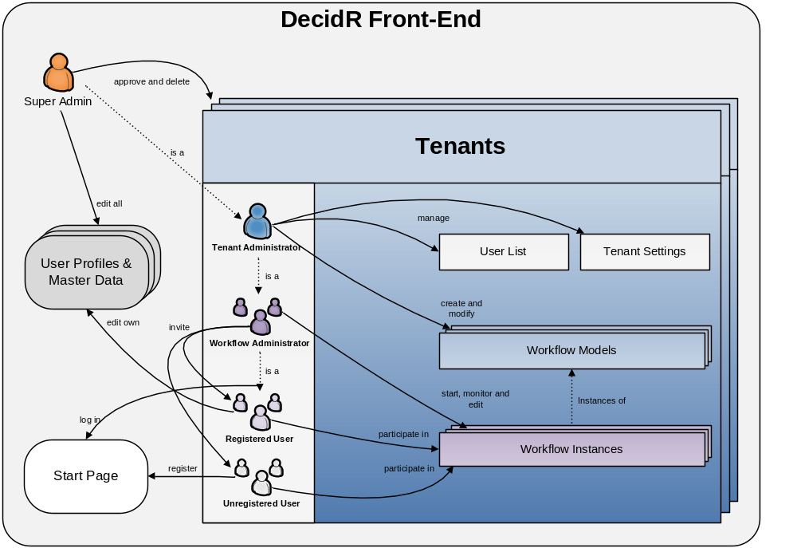
Figure 1: simplified conceptual view of the DecidR front-end

User Classes and Characteristics
The project team anticipates very diverse user groups in terms of frequency of use, technical expertise, experience and educational level. Therefore, the user classes have been distinguished by the subset of used product functions. Note that the user classes are not disjoint. For example, a tenant administrator may himself take the role of workflow admin and workflow participant. There is some correlation with the use case actors found in section 5.1.

Super Administrator
- Responsible for approving new tenants, manages the database and is capable of repairing the system if an error occurs in one of its components.
- Familiar with the system and its implementation.
- Owns all rights and privileges.
- He is the sole administrator of the default tenant.

Typical example: an IAAS staff member who is involved in the project.

Tenant Administrator
- Responsible for modeling workflows and managing tenant settings.
- Has a basic understanding of workflow management, but not necessarily BPEL.
- Owns all rights within the tenant he administrates.
- Like any other user, he may participate in workflows.

Typical examples: managers, teachers, project leaders.

Workflow Administrator
Workflow administrators are very similar to tenant administrators, except for their rights and responsibilities, which are limited to starting and managing workflow instances.

Workflow Participant
- Only deals with workflows by completing tasks on his personal work list(s).
- Doesn’t necessarily have any knowledge concerning workflow management.
- Doesn’t have any special rights or privileges that exceed participation in selected workflows and management of his personal user profile.
- May not even have registered on the DecidR web site.
- Uses his web browser and e-mail program competently, but doesn’t necessarily have any other technical or even computer science skills.

Typical examples: students, company employees.

Operating Environment
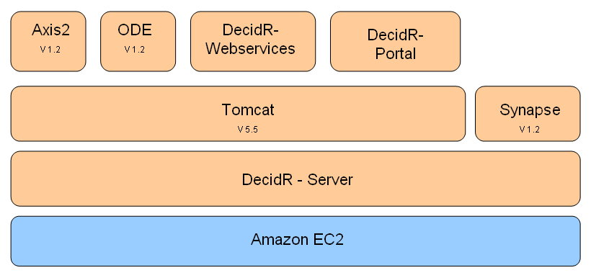
DecidR runs on the Amazon EC2, which means it is possible to adjust the computing power within minutes. It is designed to run on every system on which Synapse and Tomcat works. The whole DecidR system consists of the DecidR portal and the DecidR web services, which are used as workflow tasks. Both components are deployed on the Tomcat server. Furthermore Apache Axis2, Apache ODE and Synapse are required to execute the workflow-models and to find web services.
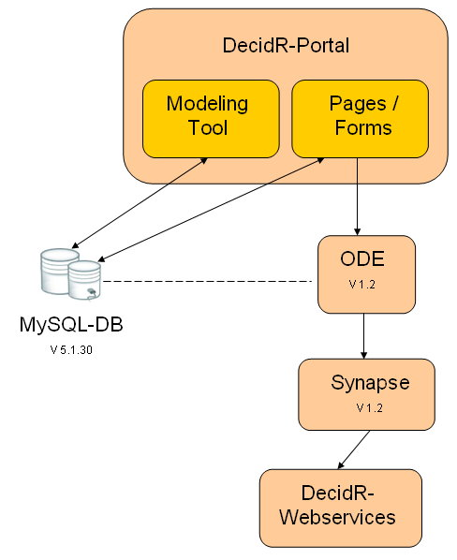
The DecidR-Portal component provides access to the DecidR-System. It is the entry point for anyone who which to model and execute decision processes with DecidR The Portal is based on Java Server Pages and includes the modeling tool and Web-Forms. The modeling tool saves the created Workflow-Models at the Database. The Pages include the function to create instances of the Workflow-Models and to execute them. The workflows are executed by the Apache ODE Engine. The several tasks in the workflow are designed as web services. These web services are accessed through Synapse ESB. If a web service is required, he ODE Engine will ask Synapse for it. Furthermore the Java Server Pages save their data at the Database.

Design and Implementation Constraints
This section describes the issues that will limit the options available to the developers during the design and implementation phases.

Third Party Components & Libraries
All used third party components and libraries must be available under a license that is compatible with [licns].

Interfaces to other applications
Users should be able to invoke external web services in workflows by supplying a WSDL 1.1 file during the modeling stage. However, this is a low priority requirement. There are no interfaces to non-web service based applications.

Technologies
All DecidR subsystems except for the front-end must be designed and implemented using web services. As WS-BPEL only supports WSDL 1.1, the DecidR web services must be described using the 1.1 revision of the standard [wsdl].
The front-end must be implemented using JavaServer Pages (JSP) and servlets [srvlt]. It will run in a Tomcat 5.5 servlet container, which limits JSP to version 2.0 and servlets to version 2.4.

Infrastructure
DecidR must be deployable in the Amazon EC2 as well as in traditional Linux or MS-Windows server environments. Therefore, the DecidR application must not rely on features, services or technologies that are exclusive to the Amazon EC2, such as the S3 storage service.

Tools
The following tools must be used for development:
- IDE:
  - Eclipse Ganymede (3.4) with Eclipse BPEL Designer plug-in
- Testing:
  - JUnit4
  - SoapUI 2.5
  - Justus
- Other documentation:
  - Microsoft Office 2003

Language Requirements
All documentation including source code comments must be written in English. Web services must be implemented using the Java language. The project team is free to use the latest Java runtime environment that is supported under the MS-Windows and Linux platforms.

Programming Standards
All code written by the DecidR project team should conform to the Java code conventions: [codcv].

User Documentation

Installation Guide
The installation guide contains the necessary steps and prerequisites to deploy the DecidR application on the Amazon EC2 as well as traditional Linux and MS-Windows server environments. Additionally, it explains the configuration files and deployment descriptors that come with the DecidR server components.

Integrated Help
While it’s a very important goal to make the DecidR front-end user-friendly and intuitive, it must provide a minimalistic integrated help system. There is no separate user manual.

Extension Guide
The extension guide should help maintainers of the DecidR application with creating additional modules or services, extending the web front-end, etc.
The guide should contain several use cases that cover the most important extension tasks.

Assumptions and Dependencies
<List any assumed factors (as opposed to known facts) that could affect the requirements stated in the SRS. These could include third-party or commercial components that you plan to use, issues around the development or operating environment, or constraints. The project could be affected if these assumptions are incorrect, are not shared, or change. Also identify any dependencies the project has on external factors, such as software components that you intend to reuse from another project, unless they are already documented elsewhere (for example, in the vision and scope document or the project plan).>
- Wir gehen davon aus, dass die gewünschte Funktionalität des Modeling-Tools mit dem Draw2D-Framework machbar ist
- Tomcat, Synapse, Axis2, ODE, MySQL, InnoDB
- Java Support für 1.6
- …

User Interface

Modeling Semantics

System Features
<This template illustrates organizing the functional requirements for the product by system features, the major services provided by the product. You may prefer to organize this section by use case, mode of operation, user class, object class, functional hierarchy, or combinations of these, whatever makes the most logical sense for your product.>

Actors

System Feature 1
<Don’t really say “System Feature 1.” State the feature name in just a few words.>

Description and Priority
<Provide a short description of the feature and indicate whether it is of High, Medium, or Low priority. You could also include specific priority component ratings, such as benefit, penalty, cost, and risk (each rated on a relative scale from a low of 1 to a high of 9).>

Stimulus/Response Sequences
<List the sequences of user actions and system responses that stimulate the behaviour defined for this feature. These will correspond to the dialog elements associated with use cases.>

Functional Requirements
<Itemize the detailed functional requirements associated with this feature. These are the software capabilities that must be present in order for the user to carry out the services provided by the feature, or to execute the use case. Include how the product should respond to anticipated error conditions or invalid inputs. Requirements should be concise, complete, unambiguous, verifiable, and necessary. Use “TBD” as a placeholder to indicate when necessary information is not yet available.>

<Each requirement should be uniquely identified with a sequence number or a meaningful tag of some kind.>

REQ-1:
REQ-2:

System Feature 2 (and so on)

Nonfunctional Requirements

Quantity Structure
< Mengengerüst>

???

Performance Requirements
DecidR needn’t fulfill any kind of higher performance requirements. It’s sufficient if the system response time is within a normal range. For more performance, the infrastructure allows to enlarge the computing power of the server on which the system is running.

Safety Requirements
<Specify those requirements that are concerned with possible loss, damage, or harm that could result from the use of the product. Define any safeguards or actions that must be taken, as well as actions that must be prevented. Refer to any external policies or regulations that state safety issues that affect the product’s design or use. Define any safety certifications that must be satisfied.>

Security Requirements
All web services and server components of the DecidR application must be designed to be resilient to attacks. Mechanisms for strong input validation and encrypted communication must therefore be considered during the design phase. Connections to the database must be secured using SSL and X509 certificates.

Password Policy
Users who are registering at the DecidR web site are required to choose a password consisting of at least eight characters. The password must contain at least one non-alphanumeric character. After five unsuccessful login attempts, user accounts are locked and must be unlocked by following a link that is sent to the user via e-mail or by waiting a few minutes. The purpose of this security measure is to prevent brute force attacks on user accounts.

Privacy Protection
Since many users use the same password on many sites, DecidR must use an authentication method that does not reveal the password even if an attacker gains access to the database. Connections to the web front-end must be secured using SSL / HTTPS.

Software Quality Attributes

Usability
High usability is a very important requirement. The web-based front-end should provide an intuitive and easily usable interface. Even users with little technical experience must be able to interact with the system. There are no requirements concerning accessibility features for blind or handicapped persons.

Extensibility and Changeability
It is almost certain that development of the DecidR application will continue in a future project with a completely different team. Typical extensions would include internationalization, creating new web services, or adding new elements to the modeling tool. Components that are subject to change include the storage backend and the web site layout.
DecidR must therefore be designed so that changes as well as extensions can be carried out with reasonable effort. Loose coupling and thorough documentation are the two main pillars that make extensions and changes to DecidR possible.

Availability
Failure of a particular web service should not cause the front-end and features that don’t depend on that web service to fail as well. Furthermore, launching additional server instances should increase the availability of the application by making use of the failover options provided by the Synapse ESB.
The project team cannot take responsibility for server outages on the side of the Amazon EC2 or due to bugs in MySQL, Tomcat, Axis2, ODE or Synapse.

Testability
Each developed web service must come with a test suite for automated unit testing. While it is difficult to provide this for the servlets that make the web front-end, automated tests will be delivered where no user interaction is required to produce meaningful input data. The same goes for the JavaScript-based workflow modeling tool.

Portability
Since the DecidR application is entirely based on Java™ there are no special portability requirements. The application is expected to be deployable in any environment where Tomcat 5.5 and Synapse 1.2 are executable. The system must be designed to allow exchanging the underlying persistent data storage within a few working days.

Robustness
The system must react in a robust way to invalid user input. This means the system should generate meaningful error messages and must not crash. Strong input validation is therefore required in all subsystems.

Business Rules
<List any operating principles about the product, such as which individuals or roles can perform which functions under specific circumstances. These are not functional requirements in themselves, but they may imply certain functional requirements to enforce the rules.>

Other Requirements
<Define any other requirements not covered elsewhere in the SRS. This might include database requirements, internationalization requirements, legal requirements, reuse objectives for the project, and so on. Add any new sections that are pertinent to the project.>

Applicable Technologies

BPEL Engine
Apache ODE 1.2 will be used as BPEL Engine.

Enterprise Service Bus
Apache Synapse 1.2 will be used as ESB.

Web Service Deployment
For the web services deployment Tomcat 5.5 and Axis2 V.1.4.1 are used.

Data Storage
MySQL database V.5.1.30 is used as data storage.

See http://www.eclipse.org/

